**Sprint 3- Agility Design Document**

**December 2, 2021**

Table of Contents

1. Executive Summary 4

1.1 Project Overview 4

1.2 Purpose and Scope of this Specification 4

2. Product/Service Description 4

2.1 Product Context 4

2.2 User Characteristics 4

2.3 Assumptions 4

2.4 Constraints 4

2.5 Dependencies 5

3. Requirements 5

3.1 Security 6

3.1.1 Protection 6

NA 6

3.1.2 Authorization and Authentication 6

NA 6

3.2 Portability 6

4. Requirements Confirmation/Stakeholder sign-off 6

5. System Design 6

5.1 Algorithm 6

5.2 System Flow chart 7

5.3 Software 9

5.4 Hardware 9

5.5 Test Plan 9

5.6 Task List/Gantt Chart Made by Anthony Pastorelli 10

5.7 Block code 10

5.8 Sensor Data 12

5.8 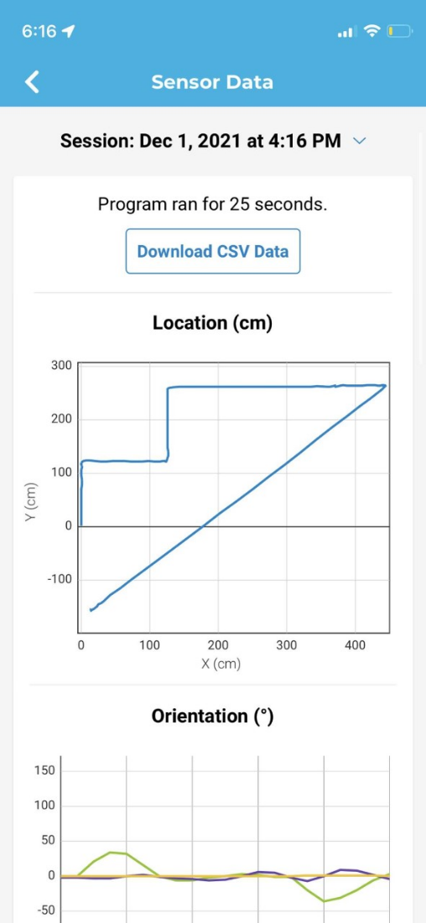 12

5.9 Staffing Plan 12

# **Executive Summary**

## Project Overview

**This Project was made as a computer science project by Jenna Esposito (manager), Thérèse Racancoj (editor), and Anthony Pastorelli (Chart Maintenance). The purpose of the project is to test the robot and see if it will follow the commands we program into it, which is to travel along the blue tape without hitting any of the bottles, jump the binder and knock over as many markers as possible.**

## Purpose and Scope of this Specification

In scope

* Agility course

Out of Scope

* Other courses

# **Product/Service Description**

## Product Context

**This is one of three parts of the Robotics Triathlon**

## User Characteristics

* **Team members**

## Assumptions

**The classroom was assumed to be available when team members needed it**

**Team members were assumed to have similar schedules**

## Constraints

* **The tiles in classroom 208 is uneven**
* **The tape does not always stay down**
* **Teammates have conflicting schedules**
* **Classroom 208 is not always available**

## Dependencies

* **This program must be run in classroom 208**
* **Requirements must be finished before the coding process can begin**

# **Requirements**

* **Robot must travel along the blue tape: The robot should stay on the blue tape as much as possible.**
* **Robot must complete the course without hitting any of the bottles: The robot must stay on course without touching any of the bottles on the ground next to the tape.**
* **Robot must go over the binder and land on course: When the robot reaches the binder it must roll up the binder and land back on the blue tape.**
* **Robot must knock over as many markers as possible: When the robot goes near the markers it should speed up to knock over all the markers if possible.**
  + **Functional Requirements**

| Req# | Requirement | Comments | Priority | Date Rvwd | SME Reviewed / Approved |
| --- | --- | --- | --- | --- | --- |
| **AGILITY_1** | **Robot must travel along the blue tape** | **N/A** | **Priority 1** | **11/18** | **11/30** |
| **AGILITT_2** | **Robot must complete the course without hitting any of the bottles** | **A low speed will help** | **Priority 1** | **11/18** | **11/18** |
| **AGILITY_3** | **Robot must go over the binder and land on course** | **Give the robot a higher speed to help it go over the binder easer** | **Priority 1** | **11/18** | **11/18** |
| **AGILITY_4** | **Robot must knock over as many markers as possible** | **Increasing the robot's speed will Increase the chances of it knocking over all the makers** | **Priority 1** | **11/18** | **11/18** |

## Security

### Protection

### NA

### Authorization and Authentication

### NA

## Portability

* **Testing was limited to classroom 208**
* **Recording the video can only be done in classroom 208**
* **Code can be done anywhere**

# **Requirements Confirmation/Stakeholder sign-off**

|  |  |  |
| --- | --- | --- |
| Meeting Date | Attendees (name and role) | Comments |
| **11/30** | **Anthony Pastorelli (Chart Maintenance), Jenna Esposito (manager), Thérèse Racancoj (editor)** | **All requirements approved** |

# **System Design**

## Algorithm

**Sprint: Agility**

**Made by: Jenna**

1. Roll up to the corner

2. Delay for ___ seconds

3. Turn 90 degrees

4. Roll up to the next corner

5. Delay for ___ seconds

6. Roll up to the third corner

7. Delay for __ seconds

8. Roll up to the binder

9. Jump over the binder

10. Roll up to the line

11. Knock down the pins at the end

12. End program

## System Flow chart

**Made by Thérèse Racancoj**

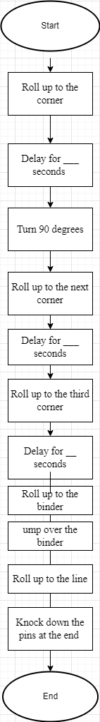

## Software

**sphero.edu app**

## Hardware

**Phone, computer, and robot**

## Test Plan

| **Reason for Test Case** | **Test Date** | **Expected Output** | **Observed Output** | **Staff Name** | **Pass/Fail** |
| --- | --- | --- | --- | --- | --- |
| **Get the correct**  **speed to complete**  **the jump but not**  **too far** | **11/23** | **Complete the jump** | **Wasn’t fast enough to clear jump** | **Anthony** | **fail** |
| **Get correct speed**  **to complete jump** | **11/23** | **Complete the jump** |  | **Anthony** | **pass** |
| **Get the correct**  **degree before**  **going straight to**  **knock over the**  **markers** | **12/1** | **Make the turn and hit the markers** | **Didn’t complete turn and missed the markers** | **Anthony** | **fail** |
| **Get the correct**  **degree before**  **going straight to**  **knock over the**  **markers** | **12/1** | **Make the turn and hit the markers** | **Completed the turn at the right degree and hit markers** | **Anthony** | **pass** |

## Task List/Gantt Chart Made by Anthony Pastorelli

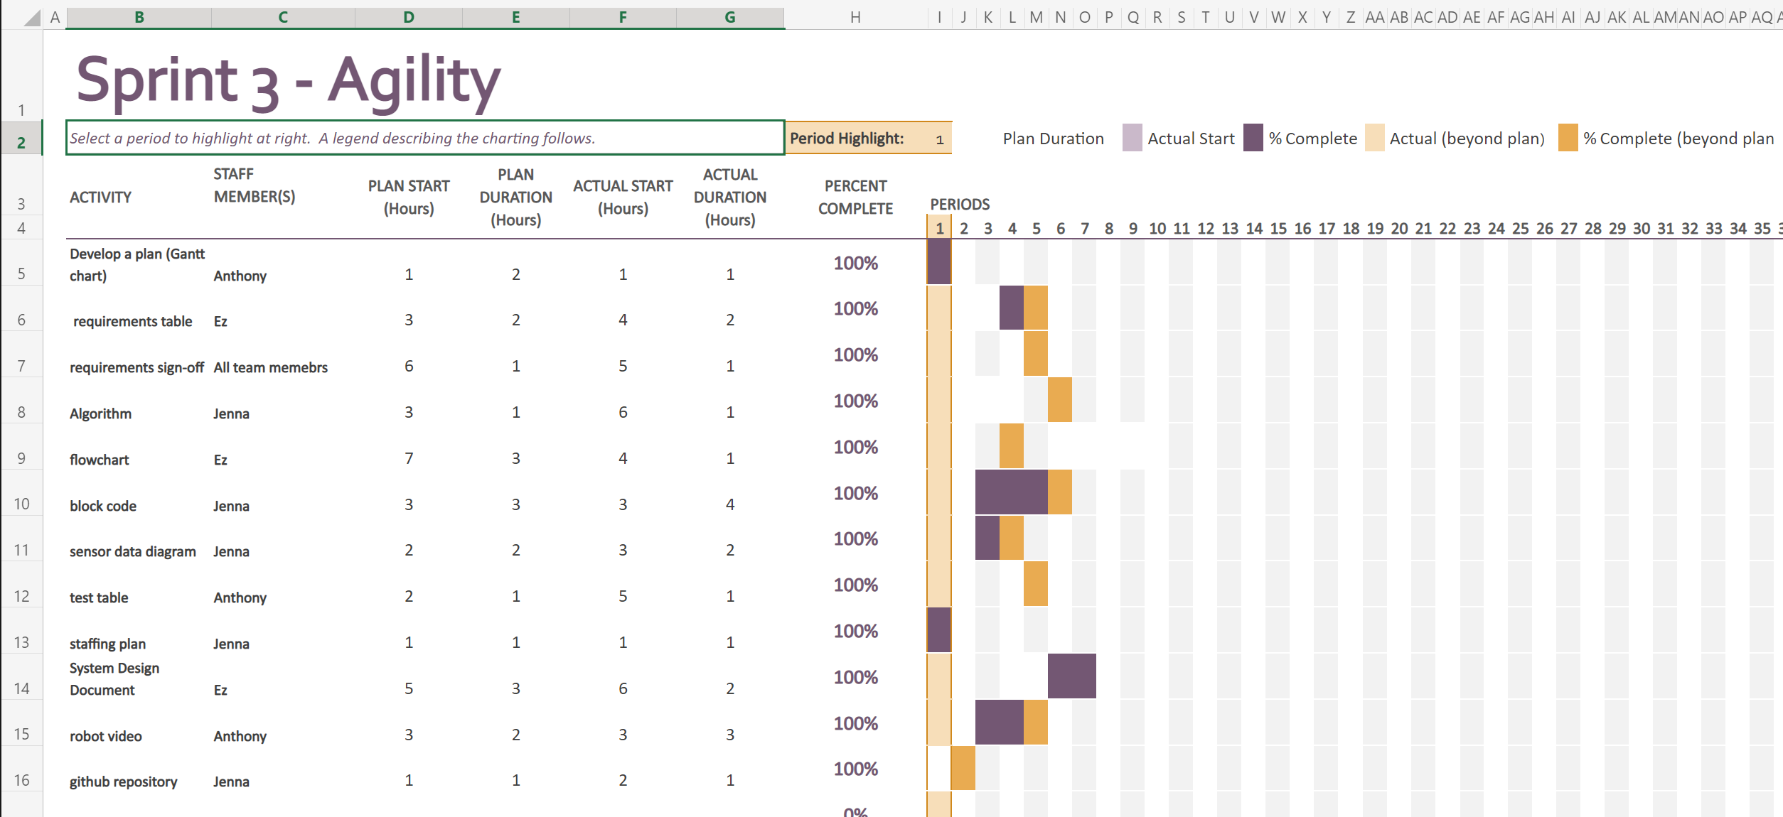

## Block code

**made by: Jenna**

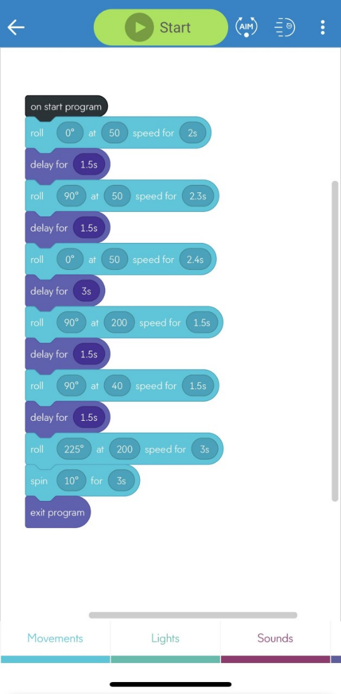

## 5.8 Sensor Data

## 

## 

## 5.9 Staffing Plan

| **Name** | **Role** | **Responsibility** | **Reports To** |
| --- | --- | --- | --- |
| **Jenna Esposito** | **Manager** | **Team management, organize staffing plan and deadlines, write algorithm, work with block code, and manage GitHub repository** | **Team** |
| **Thérèse Racancoj** | **Editor** | **Editing and finalizing**  **and filling out the doc fill out requirements table, create flowchart** | **Jenna Esposito** |
| **Anthony Pastorelli** | **Chart Maintenance** | **Maintain requirements sign-off, test table, and Gantt chart and record robot video** | **Jenna Esposito** |